**P.4 SCIENCE LESSON NOTES FOR TERM II**

**Topic : OUR FOOD**

**Food** Is something good to eat or drink and adds a nutritional value to the body.

**Feeding** Is the taking in of food into the body.

**Nutrition**: Is the process by which food is taken in and used by the body.

**Reasons why people eat food**

* It is a habit
* To reduce hunger
* To promote good health
* To show happiness
* To show hospitality

**Note**

The reasons why people eat food are summarized used the 5Hs.

* Habit Hunger Happiness Health Hospital

**Uses of food in the body**

* Provides energy
* Protects us from diseases / Boost the immunity of the body.
* Builds the body cells for growth.
* Replaces worn out body cells

**Sources of food**

* Plants
* Animals

**Places where people get food from**

* Gardens
* Shops
* Markets
* Supermarkets
* Water bodies
* Forests

**Ways people get food**

* Growing food crops
* Buying food
* Fishing
* Hunting from forests and bushes
* Gathering from forests and bushes.

**A balanced diet**

A balanced diet is a meal having all food values needed by the body in their right amounts.

**Components of a balanced diet / food values / classes of food**

* Carbohydrates
* Proteins
* Vitamins
* Mineral salts
* Fats and oils
* Water
* Roughage

**CARBOHYDRATES :** Carbohydrates are food that provide the body with energy

**Uses of carbohydrates**

* They provide energy to the bodies

**Sources of carbohydrates**

* Honey
* Bread
* Sweet potatoes
* Cassava
* Maize
* Rice

**Note :**

Carbohydrates are also called **Go food** because they provide energy to the body.

**Fats and oils**

* They are collectively known as lipids.
* Fats are solids while oils are liquids.

**Uses of fats and oils**

* They provide the body with energy.

**Sources of fats and oils**

* Simsim
* Milk
* Palm oil
* Egg yolk
* Meat

**Note**

* To much fats in the body lead to obesity.
* Fats and oils are also examples of Go foods.

**Proteins:** Proteins are foods that build the body.

**Uses of proteins in the body**

* Proteins build the body cells for growth
* Proteins replace worn out body cells

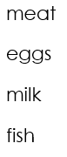**Sources of proteins**

Beans

Cow peas

Soya beans

Ground nuts

Proteins got from plants are called plant proteins like beans, cow peas, soya, ground nuts.

Proteins got from eating animal products are called animal proteins. e.g. meat, eggs, milk , fish.

Proteins are also called **Grow food** because they build the body.

**VITAMINS**

Vitamins are foods that boost the immunity of the body i.e. they protect the body against diseases.

**Types of vitamins**

Vitamins are named using capital letters thus;

* Vitamin A
* Vitamin B
* Vitamin C
* Vitamin D
* Vitamin E
* Vitamin K

**Vitamin A :**  For good eye sight

**Sources of vitamin A**

* Green leafy vegetables
* Carrots
* Raw mangoes
* Green pepper

**VITAMIN B**

* It is a water soluble vitamin
* It protects the body from skin diseases
* It promotes proper passing of messages in the body
* It is called a vitamin B complex

**VITAMIN B1**

* Enables the body to turn food into energy
* It maintains appetite

**Sources of Vitamin B1and B2**

* Beans
* Unpolished cereals
* egg yolks
* Whole grain cereals
* Kidney

**Vitamin B2** :

* It maintains the good health of the skin
* It promotes growth
* It makes energy from carbohydrates
* It makes red blood cells

**Note:**

* It is a water soluble vitamin but not destroyed by heat.

**Vitamin C**

* It promotes healing of wounds
* It assists in the absorption of iron from food.
* It prevents infection of the gum

**Note:**  It is also called ascorbic acid.

**Sources of vitamin C**

* Lemon
* Oranges
* Paw –paws
* Green pepper

**Vitamin D**

* It aids proper formation of strong bones and teeth
* It is a fat soluble vitamin

**Note:**  It is also called calciferol.

**Sources of Vitamin D**

* Liver
* Milk
* Egg yolk
* Fish
* Butter
* Margarine

**Note:** It is also formed by the skin by the help of sun light.

**VITAMIN E**

* It boosts fertility levels
* It is a fat soluble vitamins
* It is also called tocopherol

**Sources of Vitamin E**

* Eggs yolk
* Green leafy vegetables
* Liver
* Butter
* Pumpkins
* Avocado

**Vitamin K**

* It aids blood clotting at a cut.
* It aids quick healing of wounds
* It is a fat soluble vitamin

**Note**

* It is also called phylloquinona

**Sources of Vitamin K**

* Liver
* Egg Yolk
* Green leafy vegetables
* Unpolished cereals
* Carrots
* Sweet potatoes
* Tomatoes

**Note**

* Vitamins are also called Glow foods because they boost the immunity of the body.

**MINERAL SALTS**

These are foods that protest the body from diseases.

**Examples of mineral salts**

* Calcium
* Iron
* Iodine
* Phosphorus
* Sodium
* Potassium

**Calcium and phosphorus**

These are mineral salts responsible for the formation of strong bones and teeth.

**Sources of calcium and phosphorus**

* Milk
* Whole grain cereals
* Beans
* Spinach
* Fish

**Sodium and potassium**

These are mineral salts needed for balancing water levels in the body.

**IRON**

* It helps to form blood / haemoglobin
* Haemoglobin is a red pigment in blood which transport oxygen to body cells.

**Sources of iron**

* Liver
* Egg Yolk
* Green leafy vegetables
* Meat
* Beans

**Iodine**

* It aids the proper working of the thyroid glands

**Sources of Iodine**

* Sea water
* Iodized salt
* Sea weeds
* Lobster
* Shrimbsl
* Cray fish

**Note:** Mineral salts are also called Glow foods because they protect the body against diseases.

**ROUGHAGE**

Roughage is an indigestible fibre found in plants.

**Sources**

* Vegetables (leafy vegetables)
* Fresh fruits
* Sweet potatoes
* Beans
* Cassava
* Cabbage

**Uses of roughage**

* It prevents constipation
* Ease digestion of food

**WATER**

Food sources of water

* Tea
* Soup
* Milk
* Fruit juices

**Uses of water in the body**

* Water cools the body through sweating
* Makes digestion of food easy
* Water maintains the shape of body cells
* Water reduces thirst.
* Water makes up plasma in blood
* Water reduces friction in joints.

**Deficiency diseases**

These are diseases caused due to lack of some food values in the body.

**Examples of deficiency diseases**

* Marasmus
* Kwashiorkor
* Night blindness
* Beri-beri
* Pellagra
* Scurvy
* Rickets
* Haemophilia
* Anaemia
* Goitre

**Marasmus**

* It is caused due to lack of carbohydrates in the body
* It is also called starvation

**Signs of marasmus**

* Bonny face
* Loss of body weight
* Very bright eyes
* Pot belly

**Symptoms of marasmus**

* Body weakness
* Feeling hungry every time

**Control/ prevention of marasmus**

* Eating food rich in carbohydrates

**Kwashiorkor**

* It is caused due to lack of proteins in the body.

**Signs of kwashiorkor**

* Swollen moon face
* Swollen hands and seet
* Little brownish hair
* Regarded growth
* Swollen stomach full of air

**Symptoms of kwashiorkor**

* Body weakness

**Prevention / control of kwashiorkor**

* Easting food rich in proteins

**Night blindness**

* It is caused due to lack of vitamin A in the body
* It is also called poor night vision

**Signs of night blindness**

* Sore eyes
* Dry skin
* Reduced sight at night

**Symptoms of night blindness**

* Loss of appetite

**Prevention / control of night blindness**

* Eating food rich in vitamin A.

**Beri –beri**

* It is caused by lack of vitamin B1 in the body

**Signes of beri – beri**

* Retreaded growth

**Symptoms of beri-beri**

* Loss of appetite
* Body weakness

**Control / prevention of beriberi**

* Eating food rich in vitamin B1 in the body

**Pellagra**

* It is caused due to lack of vitamin B2 in the body.

**Signs of pellagra**

* Skin disorder
* Sore eyes and mouth

**Symptoms of pellagra**

* Body weakness

**Prevention and control of pellagra**

* Eating food rich in vitamin B2.

**Scurvy**

* It is caused due to lack of vitamin C in the body

**Signs of scurvy**

* Bleeding gums
* Poor healing of wounds

**Symptoms of scurvy**

* Reduced body immunity

**Prevention of scurvy**

* Eating food rich in vitamin C.

**Rickets**

* It is caused due to lack of vitamin D in the body
* It leads to suffering / softening of bones in adults called signs of rickets.
* Osteomalacia

**Signs of rickets**

* Bow legs
* Knock knee legs
* Poor teeth formation

**Symptoms of rickes**

* Weak bone

**Anaemia**

* It is caused due to lack of iron in the body

**Signs of anaemia**

* Pale skin

**Symptoms of anaemia**

* Fatigue
* Poor appetite

**Control and prevention of anaemia**

* Eating food rich in iron
* Swallowing iron tablets

**Goitre**

* It is caused due to lack of iodine in the body

**Signs of goitre**

* Swelling in the neck

**Prevention of goitre**

* Eating food rich in Iodine.

**Haemophilia**

* It is caused due to lack of vitamin K in the body.

**Signs of haemophilia**

* Poor blood clotting

**Note:** Haemorrhage is severe loss of blood

**Prevention of haemophilia**

* Eating food rich in vitamin K

**Constipation**

* It is a condition caused due to lack of roughage in the body.
* It is a condition when a person finds it difficult to pass out stool.

**Signs of constipation**

* Difficulty in passing out stool

**Symptoms of constipation**

* Pain when passing out stool

**Prevention of constipation**

* Eating food rich in roughage

**MALNUTRITION**

This is a condition when the body does not get enough food values

It is also called poor feeding

**Signs of malnutrition**

* Retarded growth
* Body weakness
* Obesity
* Chronic tiredness
* Low body immunity

**OBESITY**

Obesity is a condition of being very fat or over weight

**Conditions / factors that lead to obesity**

* Over feeding
* Eating a lot of animal fats
* Lack of physical exercises

**Dangers of being obese**

* It leads to heart diseases
* It leads to diabetes

**Signs of good health**

* Mentally alert
* Good eye sight
* Strong bones and teeth
* Having energy

**Food security**

* The way of having enough food for use at home

**Ways of ensuring food security**

* Growing drought resistant crops
* Storing excess food
* Growing more food crops
* Controlling both garden and storage pests
* Preserving surplus food
* Using good farming methods

**FOOD CONTAMINATION**

Food contamination is the way food gets into contact with germs

Food insecurity is lack of enough food for use at home.

**Causes of food insecurity**

* Drought
* Pests and diseases
* Poor methods of farming
* Floods

**Importance of food security**

* Prevents deficiency diseases
* Prevent famine

**Food hygiene**

* The keeping of food free from germs

**Ways of maintaining food hygiene**

* Washing hands before handling food
* Covering cooked food
* Putting food in clean containers
* Keeping food in clean places

**Food preparation**

* The way of making food ready for consumption.

**Ways food gets contaminated**

* Putting food on dirty containers
* Handling food with dirty hands
* When houseflies sit on food
* Serving food in a dirty place

**How to prevent food contamination**

* Re-heating leftover food
* Serving food in clean dry plates
* Covering cooked food
* Washing hands before eating food

**Ways of preparing food**

* Mingling e.g. posho, millet bread
* Boiling e.g. water, potaoes and cassava
* By frying e.g. meat, rice
* Roasting e.g. meat, fish, ground nuts, cassava, maize
* Banking e.g. cakes, bread

**Reasons for preparing food**

* To make it soft
* To kill germs
* To make it tasty

**Preparing a local dish (Practical)**

**Food preservation**

This is the keeping of food for a long time without going bad.

**Modern methods**

* Refrigeration
* Pasteurization

**Local / traditional**

* Smoking
* Salting
* Sun drying

**Ways of preserving food**

* Smoking e.g. fish, meat
* Sun drying e.g. cassava, millet, sorghum, ground nuts
* Salting e.g. fish, meat
* Refrigeration e.g. fruits, fish, meal, milk
* Pasteurization

**Importance of preserving food**

* To keep food for future
* To ensure food security

**HUMAN BODY ORGANS**

The human body is formed from smallest units called cells.

Cells form tissues, tissues form organs, organs form systems and systems form an organism.

**Body organs**

|  |  |
| --- | --- |
| Eyes  Ear  Brain  Liver  Urinary bladder | Stomach  Kidney  Lungs  Heart |

**Eyes**

* They are used for seeing or sight
* They use light to fun ction

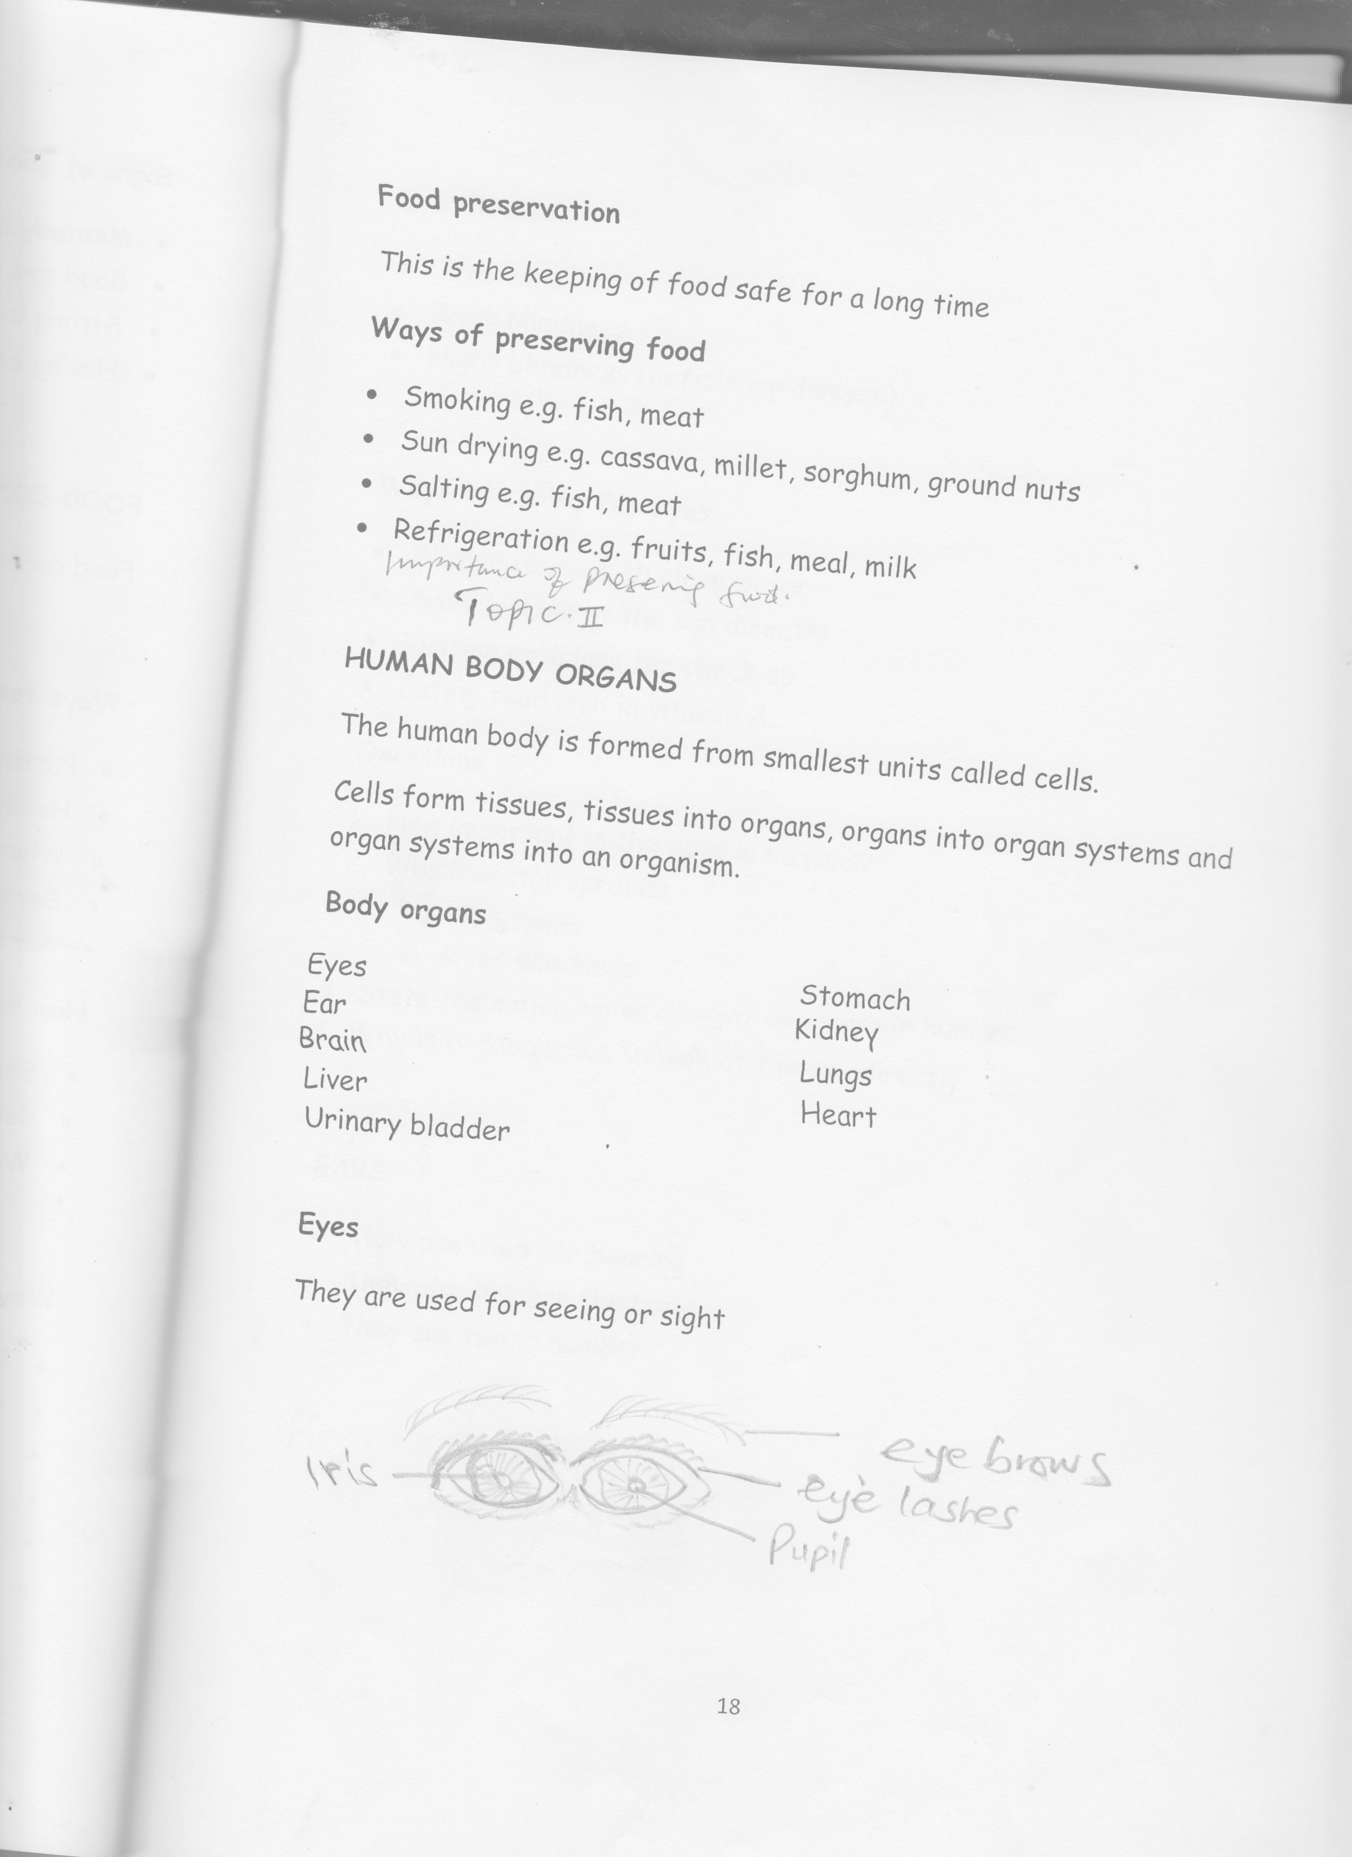

**Eye diseases**

* Trachoma
* River blindness
* Night blindness (deficiency disease)
* Conjuctivities
* Stye

**Ways of caring for eyes**

* Washing eyes with clean water
* Avoid looking at the sun directly
* Visiting opticians for check up
* Eating food rich in vitamin A.

**Questions**

1. How important is the nose in humans?
2. Which vector spreads
   1. Trachoma
   2. River blindness
3. State the major cause of night blindness in humans.
4. Why is it dangerous to look at the sun directly

**EARS**

* They are used for hearing
* They also balance the body
* They are two in number

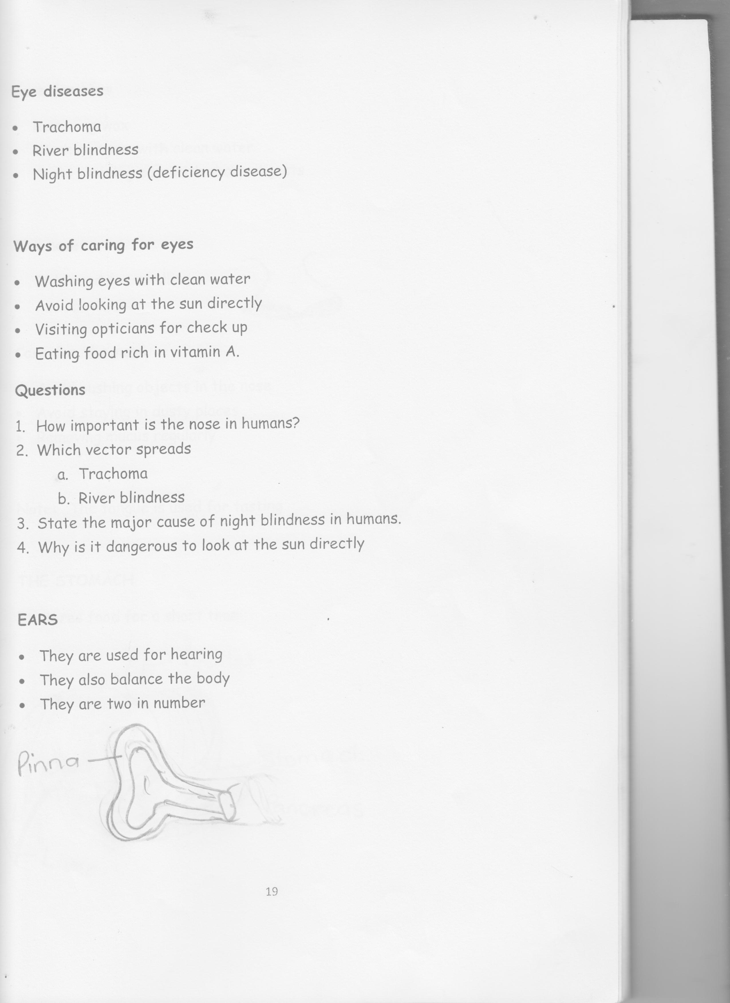

(Collects sound waves)

**Care for ears**

* Removing wax using ear pads
* Washing them with clean water
* Avoid cleaning ears with sharp objects

**The nose**

* 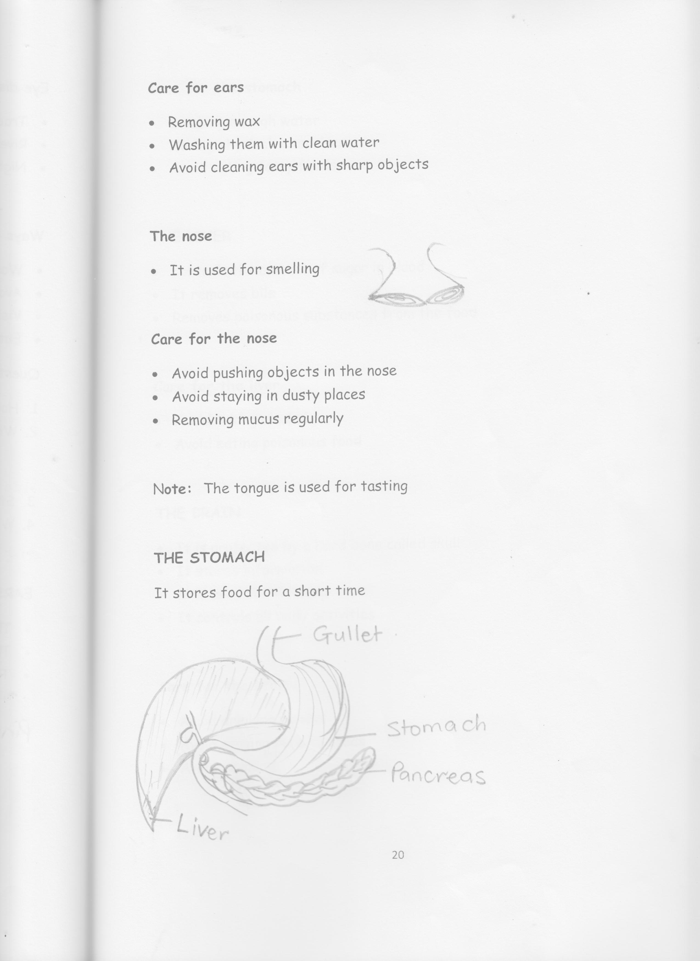It is used for smelling

**Note**

* The small hair in the nose is cilia
* Cilia traps germs and dirst
* Air in the nose is warmed, filtered and moistened.

**Care for the nose**

* Avoid pushing objects in the nose
* Avoid staying in dusty places
* Removing mucus regularly

N**ote:**  The tongue is used for tasting food

**THE STOMACH**

It stores food for a short time



**Care for the stomach**

* Drinking enough water
* Having physical exercises
* Avoid eating fatty foods

**THE LIVER**

* Controls the amount of sugar in blood
* It produces bile
* It makes poisonous substances from the food harmless

**Diseases of the liver**

* Liver cancer
* Liver cirrhosis
* Liver abscess (boils)

**Care for the liver**

* Avoid taking alcohol
* Avoid eating poisonous food

**THE BRAIN**

**Note:** It is protected by a hard bone called skull

* It stores information
* It is used for thinking
* It controls all body activities
* For memory

**Diseases of the brain**

* Cerebral malaria
* Meningitis
* Stroke
* Epilepsy
* Brain cancer

**Care for the brain**

* Avoid drinking alcohol
* Avoid staying in noisy areas
* Avoid smoking

**LUNGS**

* They are used for breathing
* They are two in number

Wind pipe

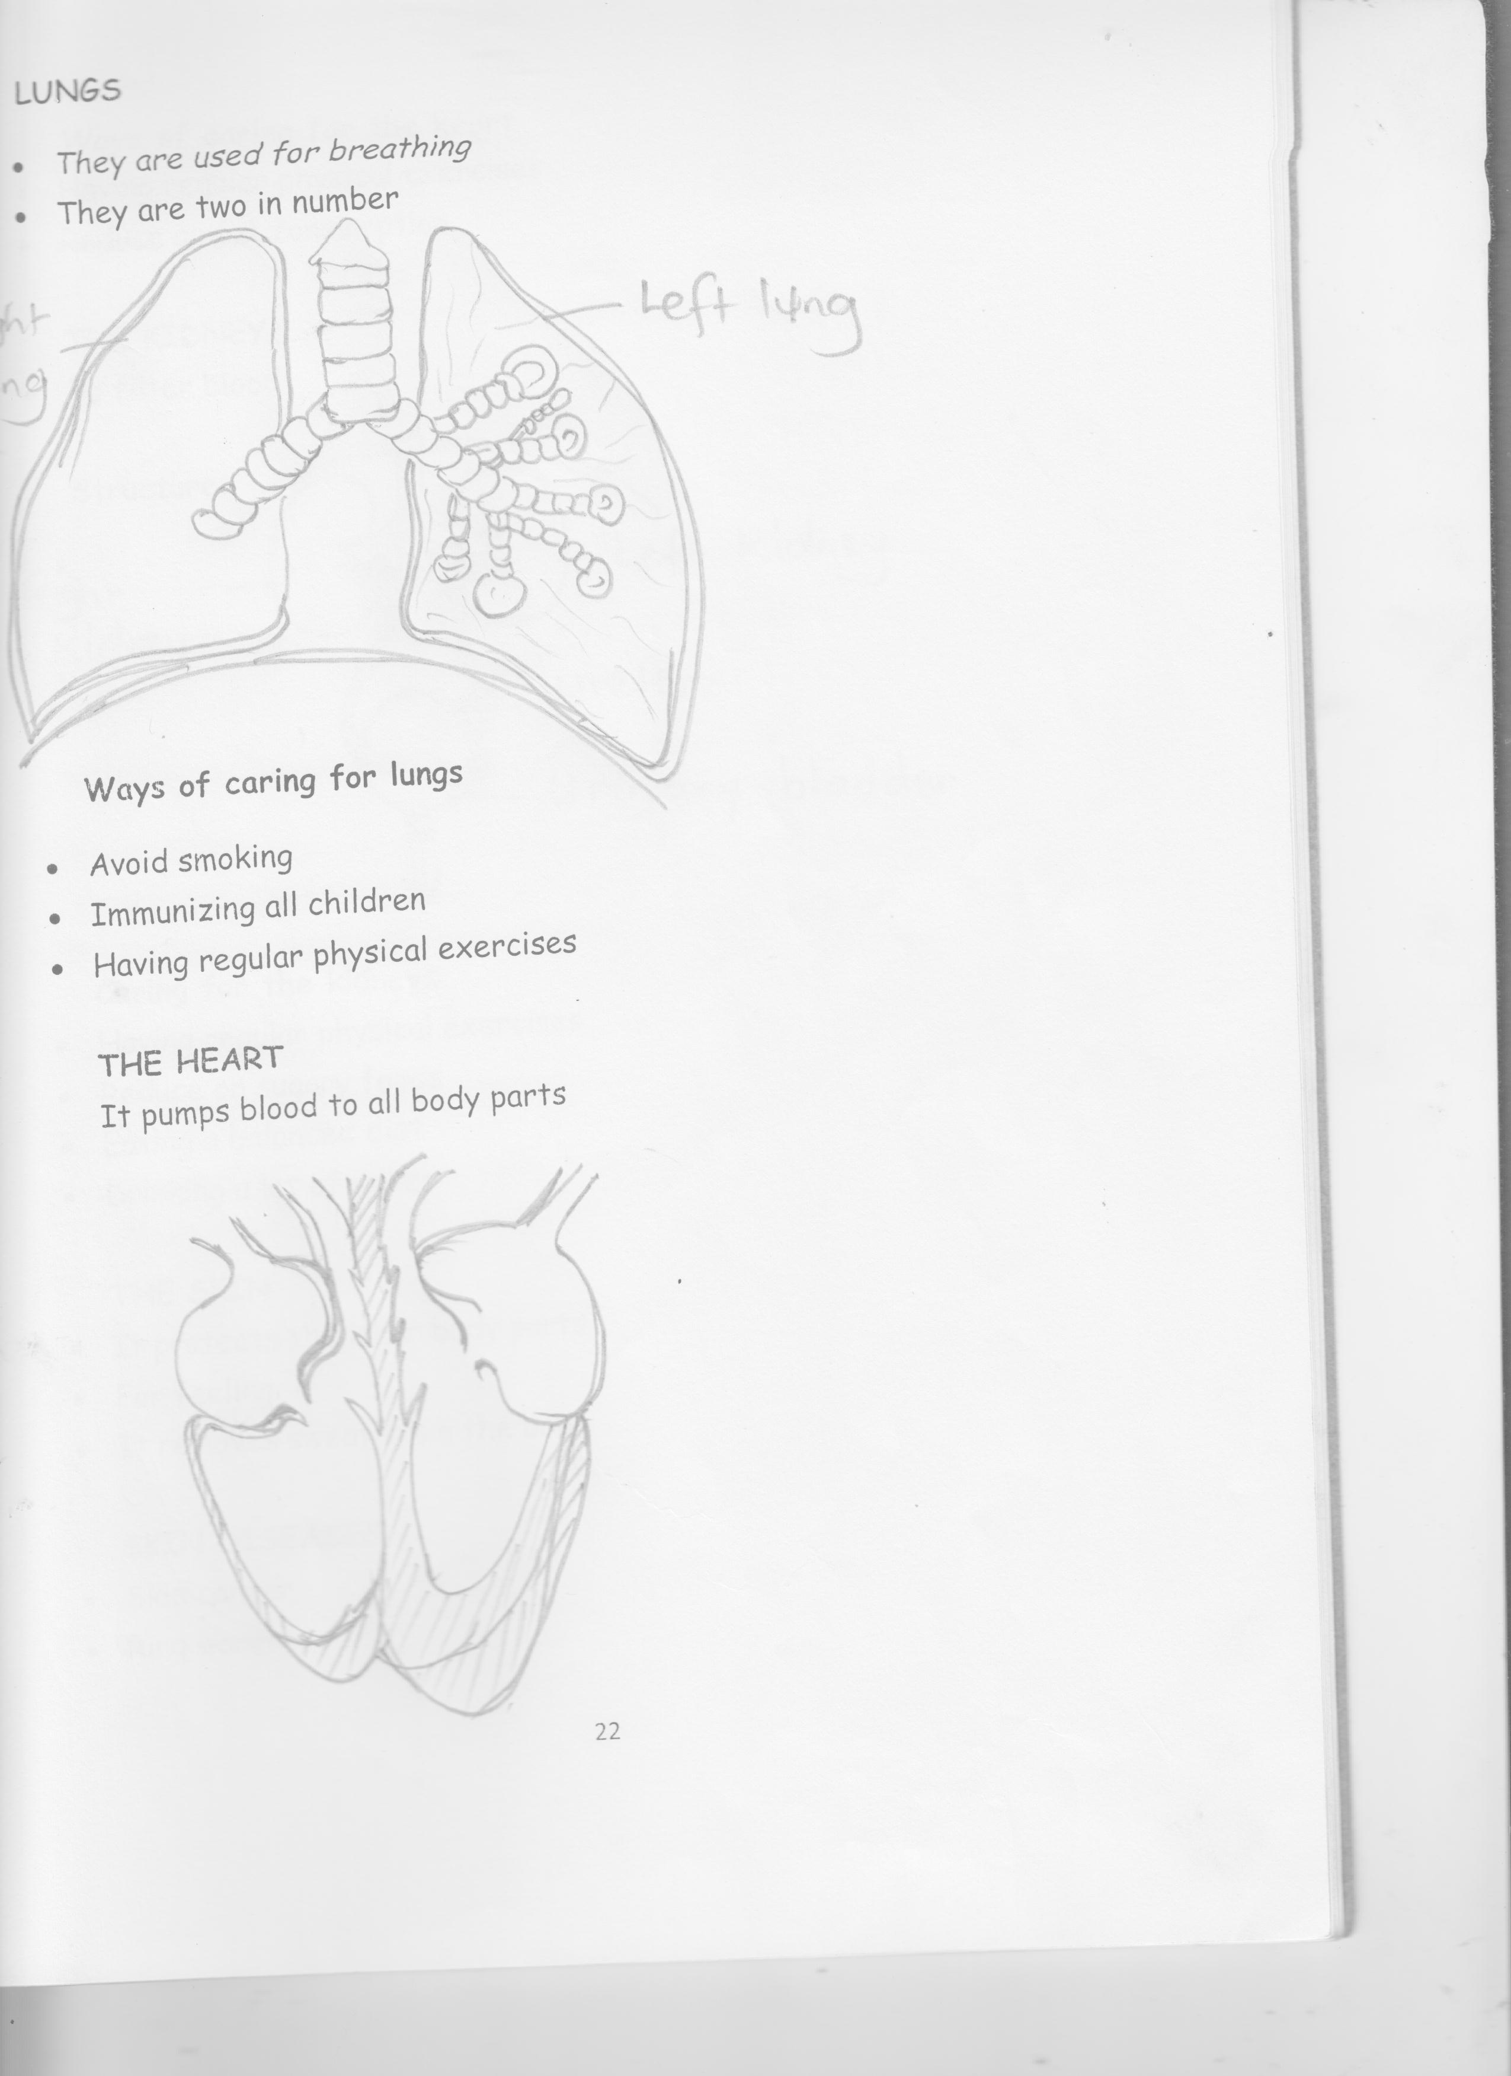

Left lung

Air sacs (alveoli)

Right lung

diaphragm

**Ways of caring for lungs**

* Avoid smoking
* Immunizing all children
* Having regular physical exercises
* Eating a balanced diet
* Keeping away from dusty places

**THE HEART**

It pumps blood to all body parts

Pulmonary artery aorta pulmonary vein



Right strium

(auricle) left atrium

(auricle)

Right ventricle left ventricle

**Ways of caring for the heart**

* Having regular physical exercises
* Reduce on fat consumption
* Eating a balanced diet
* Having enough rest

**THE KIDNEY**

* To filter blood

**Structure**

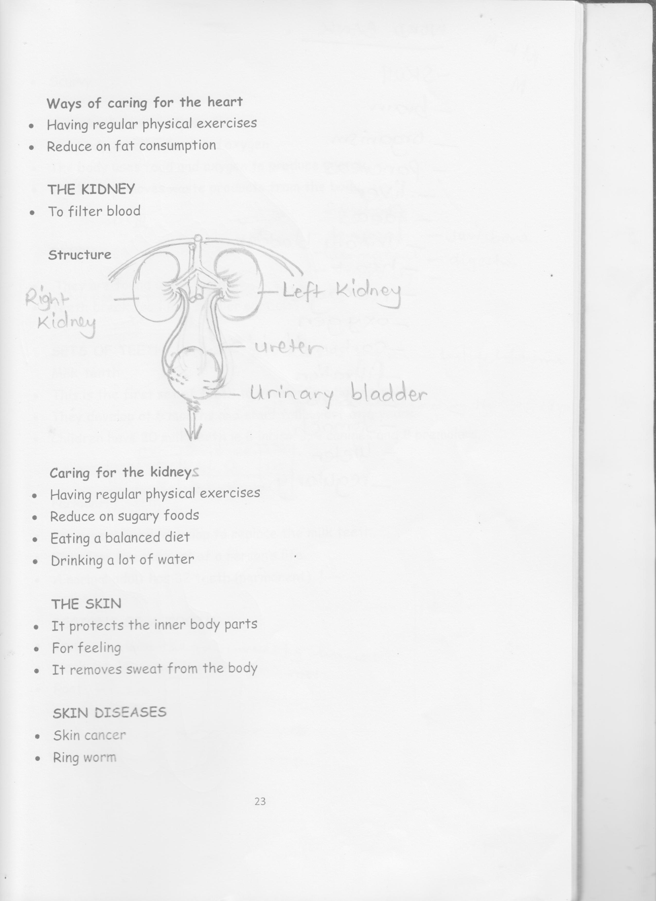

**Functions of the above parts**

* Ureter – takes urine from the kidney to the urinary bladder.
* Urinary bladder – stores urine for a short time.
* Urethra – takes out urine from the body

**Diseases of the kidney**

* Kidney cancer
* Nephritis
* Citisis

**Caring for the kidney**

* Having regular physical exercises
* Reduce on sugary foods
* Eating a balanced diet
* Drinking a lot of water

**THE SKIN**

**Note:** It protects the inner body parts

* For feeling
* It removes sweat from the body
* Controls body temperature
* Makes vitamin D using the sunlight

**SKIN DISEASES**

* Skin cancer
* Ring worm
* Scurvy
* Pellagram
* Measles
* Scabies
* Dobhi itch
* Impetigo
* Candidiasis

**How the human body works**

* The body takes in food and oxygen
* The body uses food and oxygen to produce energy
* The body removes waste products from the body.
* Carries food and oxygen to different parts of the body.

**Word bank**

* skull
* brain
* organism
* pancreas
* liver
* faeces
* urinary bladder
* heart
* ribcage
* oxygen
* carbon dioxide
* filtration
* absorb
* stomach
* ureter
* regularly

**TOPIC III**

**Spellings**

* temporal
* permanent
* temporary
* jaw bone
* digestion

**TEETH**

* They are found in the mouth
* Teeth break food into smaller particles

**SETS OF TEETH**

A person gets two sets of teeth in his / her life time namely;

**Milk teeth**

* This is the first set of teeth to develop in a baby’s mouth.
* They develop at 6 months and all of them are removed by the age of 13 years.
* Children have 20 milk teeth ie 8 incisors, 4 canines and 8 premolars.

|  |  |  |  |  |
| --- | --- | --- | --- | --- |
|  | Incisor | Canine | Premotor | Total |
| Lower | 4 | 2 | 4 | 10 |
| Upper | 4 | 2 | 4 | 10 |
| Total | 8 | 2 | 8 | 20 |

**Permanent teeth**

* Permanent teeth develop to replace the milk teeth.
* They last for the rest of a person’s life
* A normal adult has 32 teeth (permanent)

**REGIONS OF A TOOTH**

* Crown - above the gun covered by enamel
* Neck - between the crown air root
* Root – inside the gum

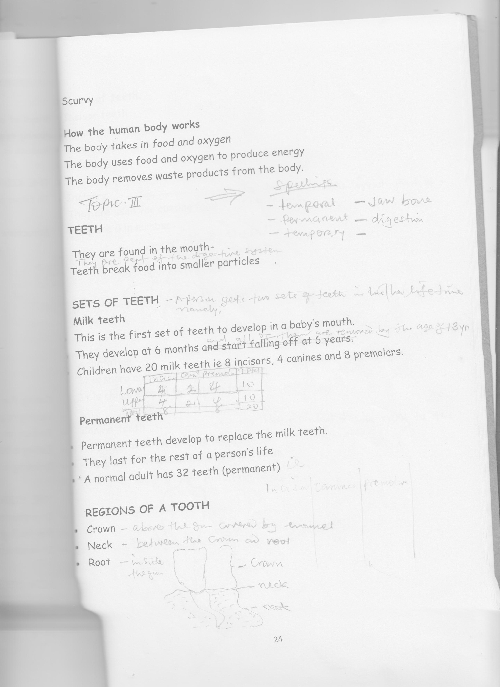

**Types of teeth**

* Incisor teeth
* Premolars
* Canine teeth
* Molar

**Incisors -** The teeth in the front part of the mouth

* They are used for cutting food
* They are 8 in number

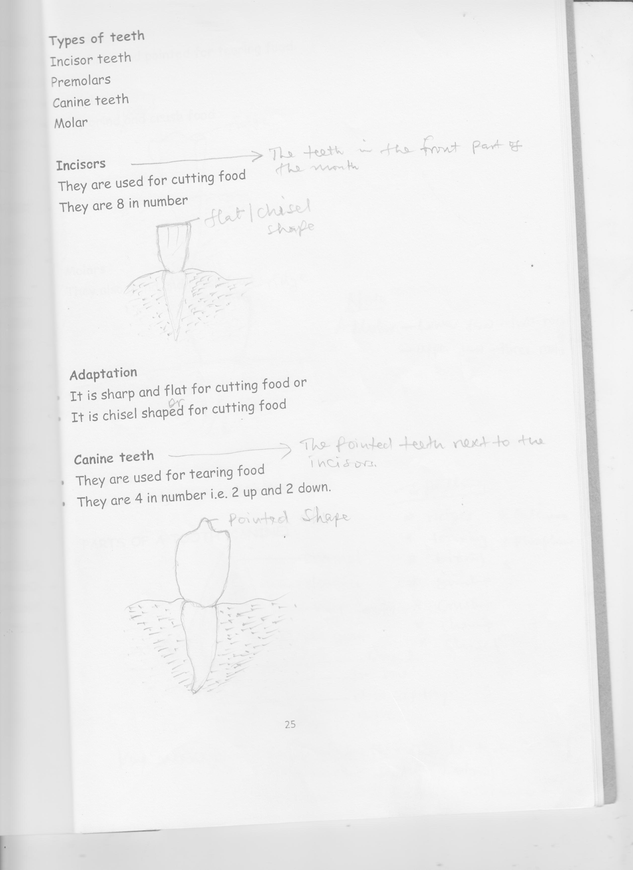

**Adaptation**

* It is sharp and flat for cutting food or
* It is chisel shaped for cutting food

**Canine teeth -** The pointed teeth next to the incisors.

* They are used for tearing food
* They are 4 in number i.e. 2 up and 2 down.



**Adaption**

It is sharp and pointed for tearing food

**Premolar**

* They grind, chew and crush food

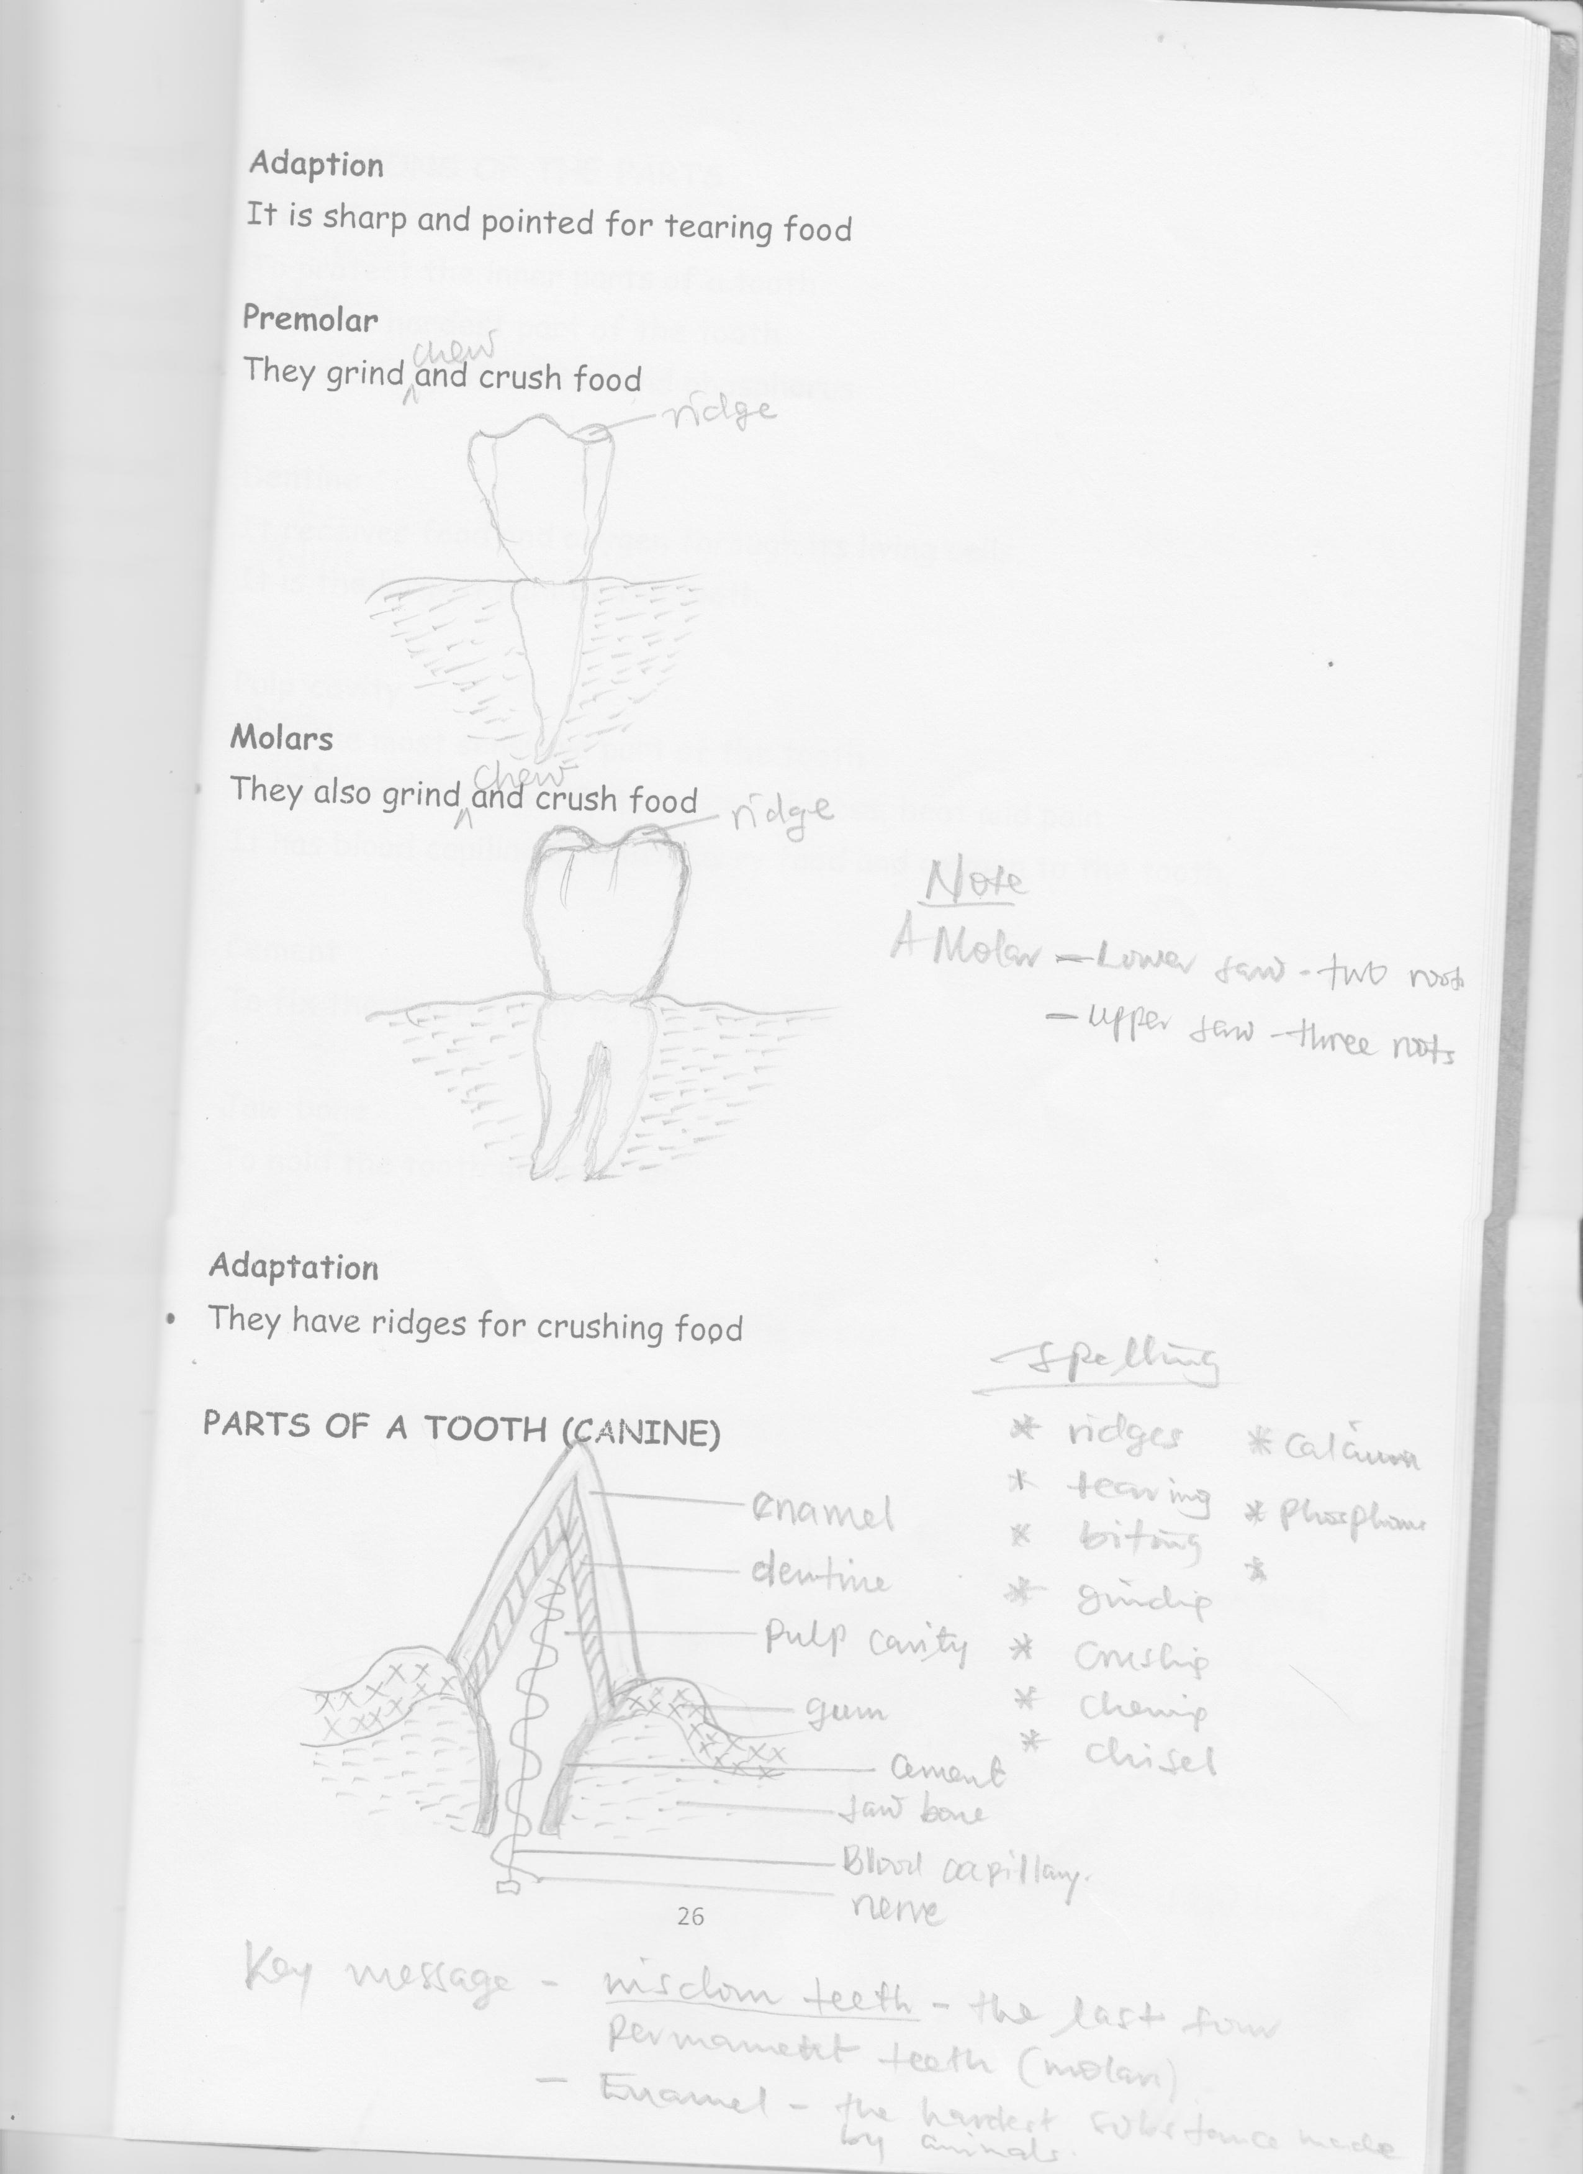

**Adaption**

They have rough edges / cusps for chewing, grinding and crushing food

**Molars**

* They also grind, chew and crush food



Note: A molar - Lower jaw-two roots

- Upper jaw – three roots

**Adaptation**

* They have ridges for crushing food

**Parts of a canine tooth**



**Note: A molar** – Lower jaw – two roots

- Upper jaw three roots

**FUNCTIONS OF THE PARTS**

**Enamel**

* To protect the inner parts of a tooth

**Note**

* It is the hardest part of the tooth
* It is made up of calcium and phosphorus

**Dentine**

* It protects the pulp
* It has living cells which make it sensitive

**Note**

* It is the largest part of the tooth.

**Pulp cavity –** hole

**Note –** nerves and blood capillaries

**Nerves** are the most sensitive part of tooth

**Nerves –** they sense pain, heat and cold

**Blood capillary –** supply oxygen and food to the tooth.

**Cement**

* To fix the tooth firmly to the Jaw bone

**Jaw bone**

* To hold the tooth in a position

**Gum:**

* To give the tooth extra support to a tooth in the socket.

**PARTS OF A TOOTH (MOLAR)**

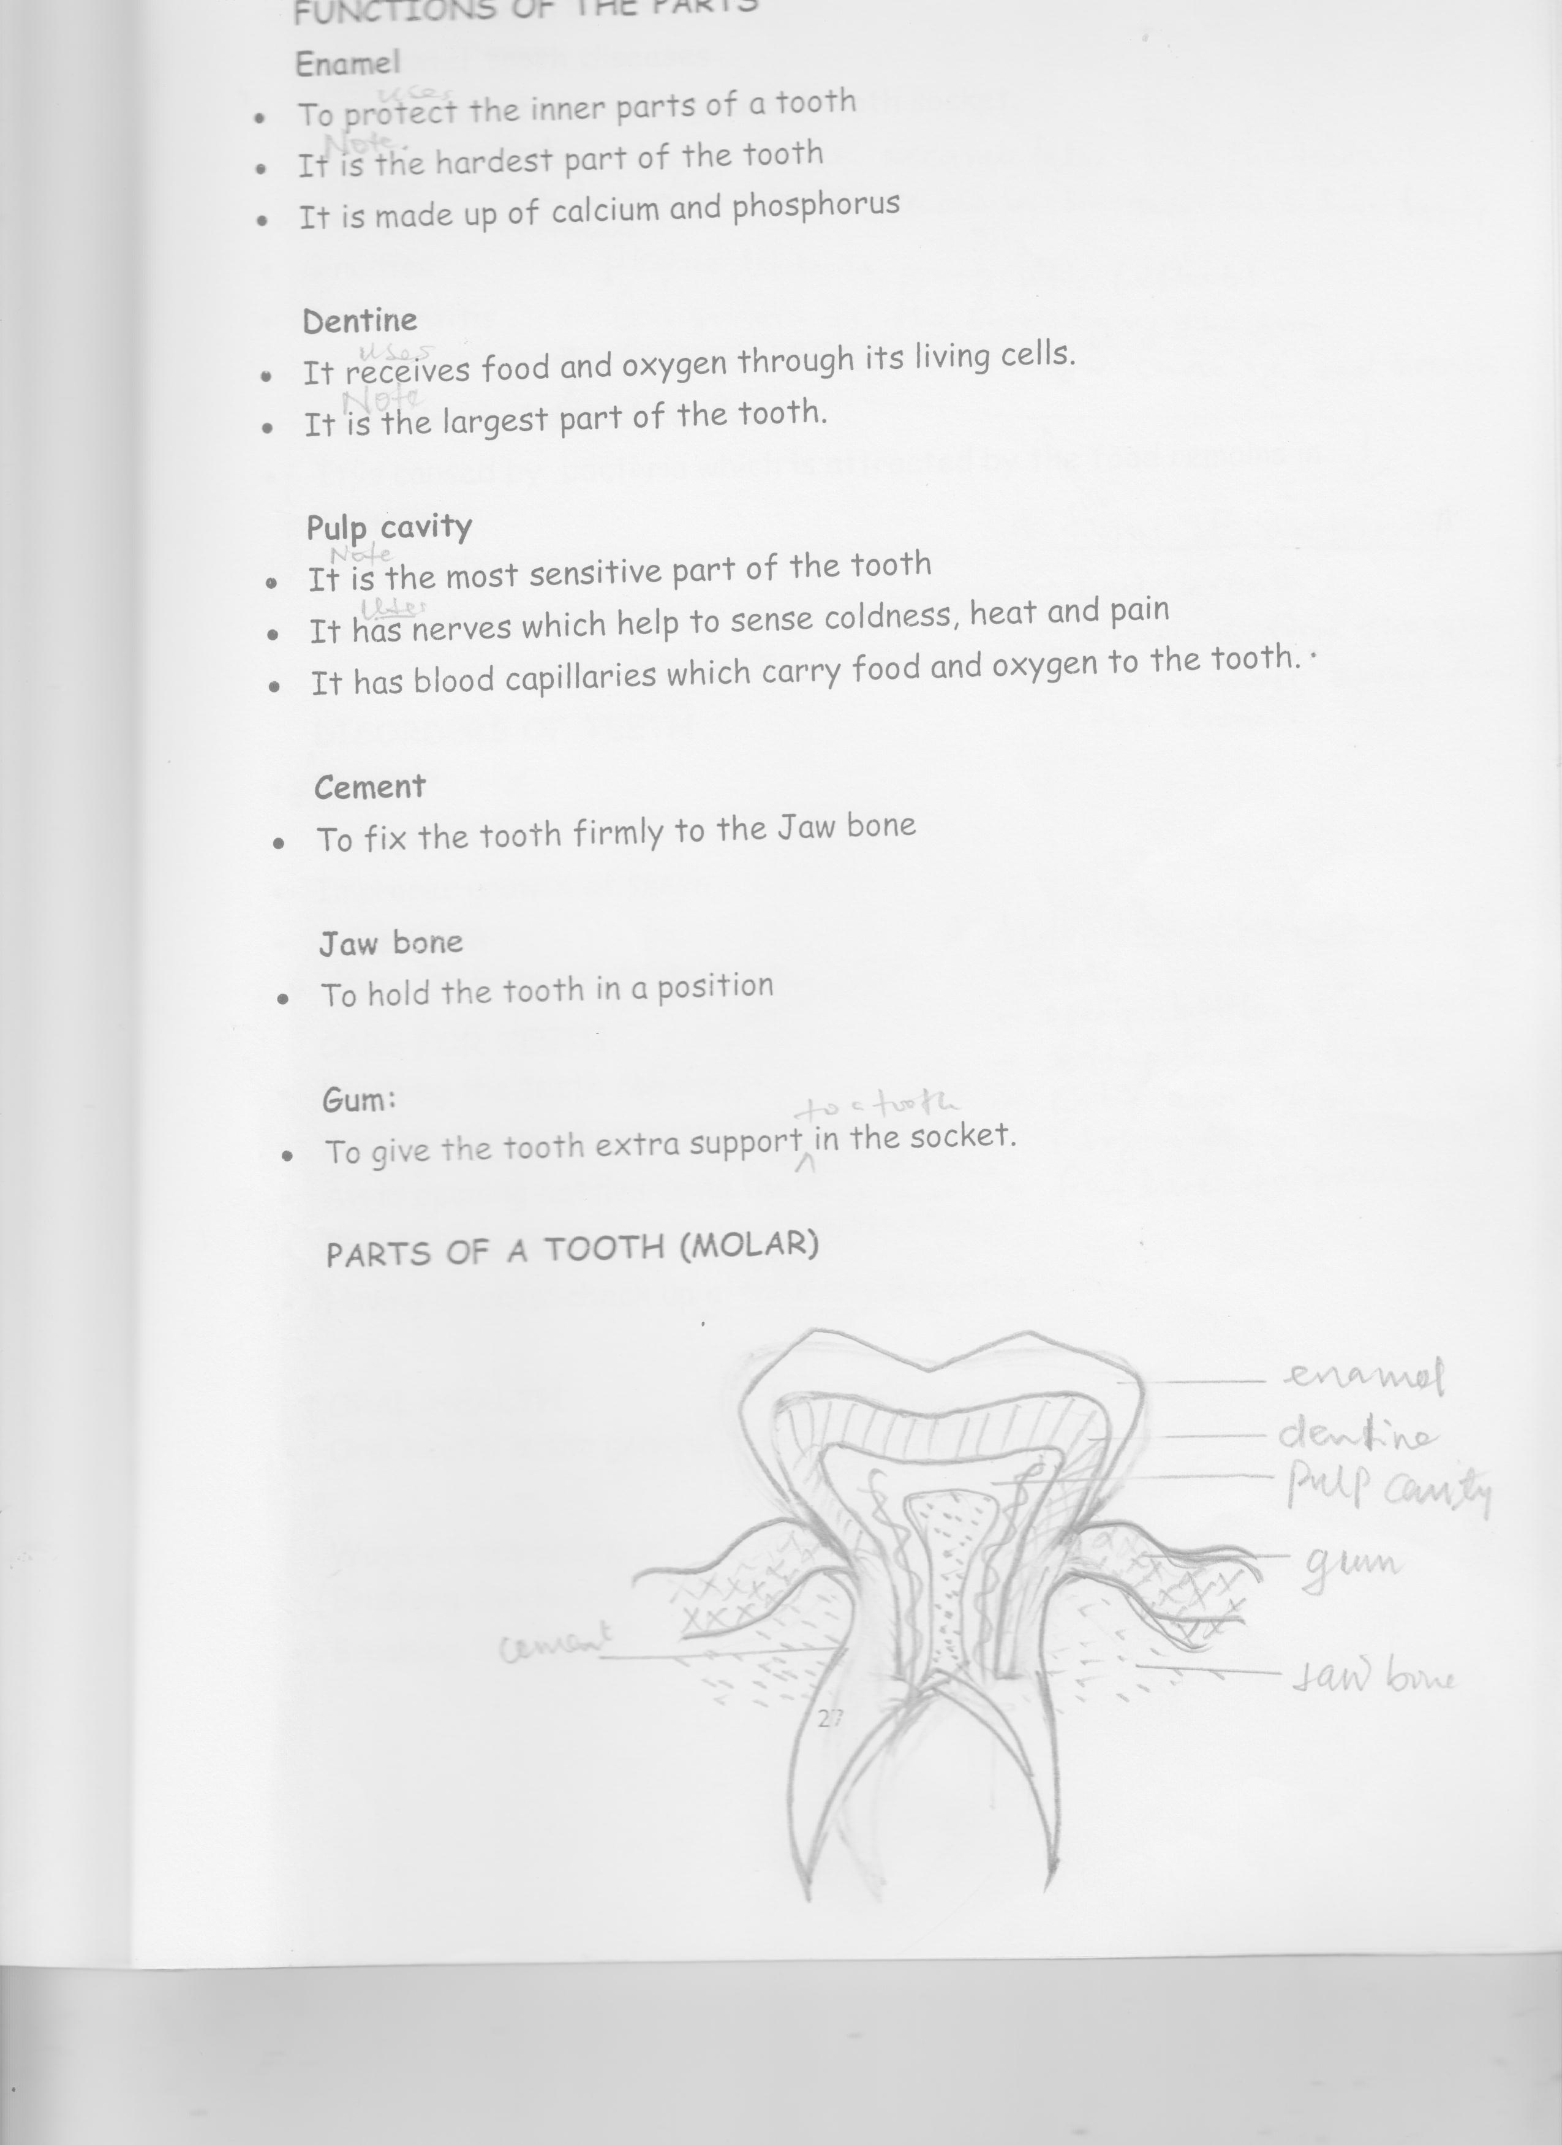

**Disease of teeth**

* Tooth decay
* Periodontal diseases

**DISEASES OF TEETH**

**Periodontal tooth diseases**

**Note**

* It is the infection on the gum and tooth socket.
* It is caused by plaque which accumulates on the teeth
* Plaque is the coating on teeth caused by bacteria and saliva having mucus
* Plaque leads to giving vityic (effects)
* Givingivitis is the swelling of the gum
* Gingivitis is the major cause of bad breath.

**Signs of gin of gingivitis**

* Bad breath
* breeding from the gum
* gum moves away from the crown

**Tooth decay / dental carries.**

* It is caused by bacteria which is attracted by the food remains in the teeth.

**DISORDERS OF TEETH**

* Broken teeth
* Improper growth of teeth
* False teeth
* Poor alignment of teeth

**Activities that can destroy teeth**

* Opening bottles using teeth
* Biting hard objects
* Easting a lot of sweet things (sugary thing)
* Failure to brush teeth

**CARE FOR TEETH**

* Brushing the teeth daily
* Avoid eating much sweets (remains of sweets attract bacteria which cause tooth decay)
* Avoid opening bottles using teeth
* Flossing the teeth
* Having a dental check up after every 6 months.

**Note**: Dental floss – a strong

**ORAL HEALTH**

* Oral health is the general cleanliness of the mouth

**Materials used for cleaning teeth**

* Water
* Dental floss
* Tooth paste
* Tooth brush
* Ash
* Salt

**Ways of promoting oral health**

* Brushing the tongue
* Brushing the teeth
* Rinsing the mouth with warm salty water.
* Visiting the dentist for check up

**Activity**

1. Why do we brush our teeth?
2. Name any two diseases of teeth
3. In which way is the canine tooth adapted to its function?
4. What is oral health?
5. Give two ways of caring for teeth.
6. Why do we brush teeth?

**Word bank**

1. Milk teeth
2. permanent
3. enamel
4. incisors
5. canines
6. premolars
7. molars
8. crushing
9. cwewing
10. food particles
11. plague
12. crown
13. breath
14. dental flossing
15. cracked teeth
16. gingivitis
17. periodontitis
18. periodontal
19. tartar
20. dental brace
21. biting
22. oral hygiene
23. calcium

Topic V

**SANITATION**

* Sanitation is the general cleanliness of an area where we stay / live

**Importance of proper sanitation**

* Controls diarrhoeal diseases
* Controls bad smell
* Controls disease vectors

**Things used to clean our environment**

* Hoes
* Brooms
* Water
* Slasher
* Scrubbing brush
* Liquid soap

**Ways of promoting sanitation**

* Collecting rubbish
* Sweeping the compound
* Mopping the floor
* Smoking pit latrines
* Proper disposal of rubbish
* Proper disposal of human wastes

**Dangers of poor sanitation**

* Leads to diarrhea disease
* Leads to bad smell
* Increases vector

**Indicators of poor sanitation**

* Bad smell
* Human waster
* Presence of house rubbish

**Diseases spread due to poor sanitation**

* Diarrhea
* Dysentery
* Typhoid
* Cholera
* Malaria
* Trachoma
* Polio
* Bilharziasis

**Elements of a clean home**

* Latrine: for proper disposal of human wastes
* Rubbish pit: for proper disposal of rubbish.
* Kitchen: It is where we cook and store food
* Plate stand: It is where we put plates to dry
* Bath room: it is where we bathe from.

**GERMS / PATHOGENS**

* Germs are tiny organisms which cause diseases.
* Germs are so small that they can’t be seen with our naked eys.
* We use a microscope to see germs
* Microscopes enlarge germs

**Types / groups of germs**

* Bactria
* Fungi
* Viruses
* Protozoa

**Examples of bacteria**

* Bacilli which caused tuberculosis
* Vibrio cholera which cause cholera
* Salmonella typhi which causes typhoid
* Chlamydia which cause trachoma
* Cocci –

**Examples of viruses**

* Human Immune Deficiency Virus – AIDs
* Polio Virus – Polio
* Pneumococcal virus – Pneumonia
* Yellow fever virus

**Examples of protozoa**

* Plasmodia – malaria
* Trypanosomes – sleeping sickness and nagana
* Amoeba – amoebic dysentery

**Fungal diseases**

* Candida
* Trychomona

**Examples of fungal diseases**

* Ring worm
* Anthletes foot
* Candidiasis

**Places where germs are found**

* In water
* Air
* In blood
* In the soil
* Rubbish pit
* Latrine
* Our bodies
* Rotting matter

**Ways in which germs spread**

* Through breathing in contaminated air
* Through body contacts
* Through animal bites
* Through cuts on the body
* Through sharing clothes with an infected person.
* Through eating contaminated food
* Drinking contaminated water

**Ways of controlling the spread of germs**

* Covering cooked food
* Washing hands after visiting the latrine
* Proper disposal of human wastes
* Collecting and burning rubbish

**THE FOUR Fs**

* Faeces – Flies – Food – Fingers

**DISEASES SPREAD THROUGH THE 4FS**

* Cholera
* Typhoid
* Dysentery
* Diarrhea

**How to prevent diseases spread through 4Fs**

* Proper disposal of aeces
* Covering cooked food
* Washing hands after visiting the latrine
* Washing hands before eating

**Causes of sickness at home**

* Poor feeding
* Poor sanitation
* Lack of physical exercises
* Lack of enough rest

**Prevention of diseases without use of drugs**

* Eating food having a balanced diet
* Promoting proper sanitation
* Doing regular physical exercises
* Have enough sleep

**Work bank**

* germs
* organisms
* diseases
* microscope
* tine
* bacteria
* diarhoea
* rotting
* sanitation
* cleanliness
* general
* stagnant
* mosquitoes
* defecation
* dysentery
* typhoid
* rehydration
* dehydration